

**UNIVERSITY OF PETROLEUM & ENERGY STUDIES**

**Dehradun**

**Application Containerization**

**Experiment 6**

**Name: Sarthak Jain**

**Course: B-Tech CSE DevOps (2018-22)**

**Roll number: R171218088**

**Sap ID: 500069614**

**Experiment 6: Docker Linking and Monitoring**

**Aim**

**To create containers and link them.**

**Steps Performed**

**- Run a container in detach mode (-d) with name "db" and image "traning/postgress" `docker run -it -d --name db training/postgress`**

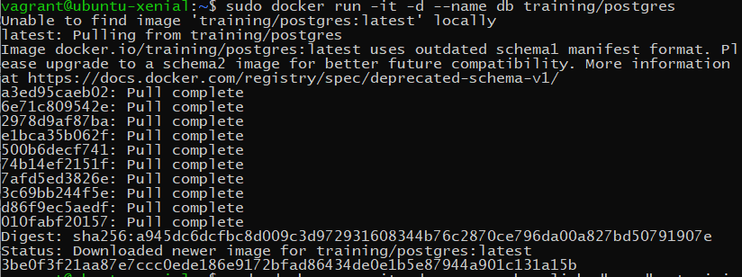

**- Run another container in detach mode with name "web" and image "training/webapp" and link it to container "db" with alias "mydb". `docker run -it -d -–name web -–link db:mydb training/webapp**

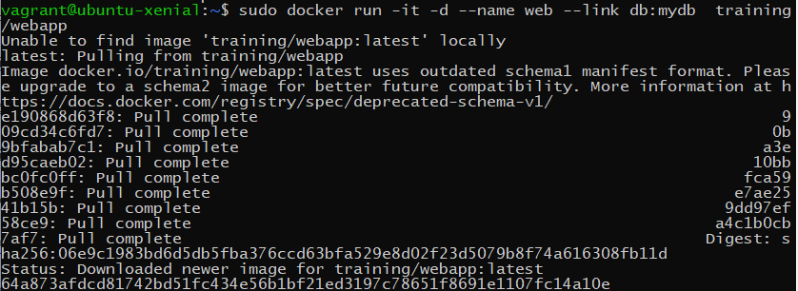

**- Run `docker exec -it web bash` and run `ping mydb` to verify connection.**

